Full Stack Development

Name : Vijay M

Reg. No. : 731621106058

Email : [vijayraja362004@gmail.com](mailto:vijayraja362004@gmail.com)

Branch : BE – ECE

College : KSRIET

SQL TASK – (8- Aug-2024)

1. **Retrieve all columns from the Sales table.**

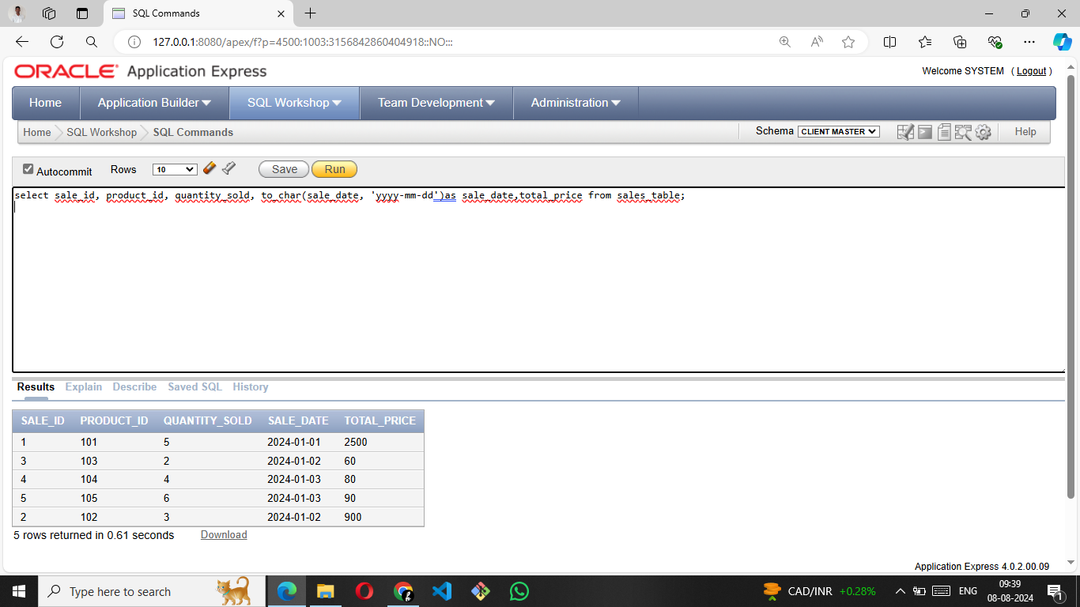

1. **Retrieve sale_id and quantity_sold from sales table.**

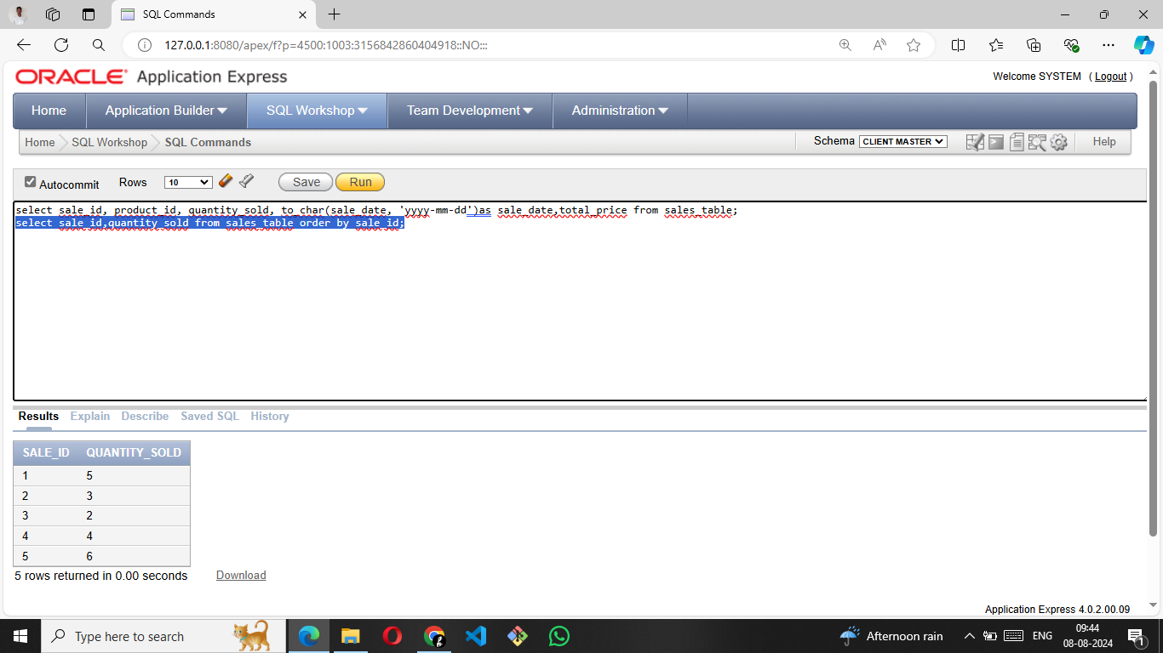

3. **Retrieve the sale_id and sale_date from the Sales table.**

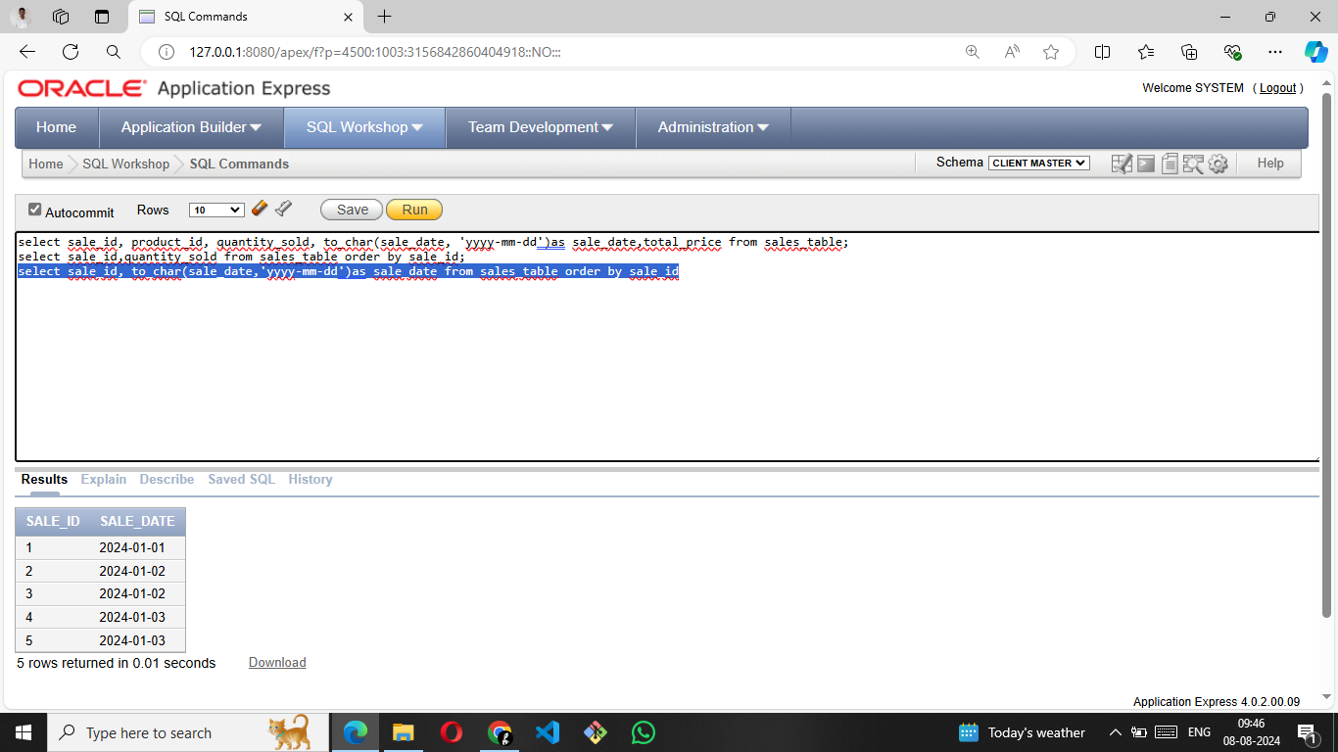

1. **Filter the Sales table to show only sales with a total_price greater than $100.**

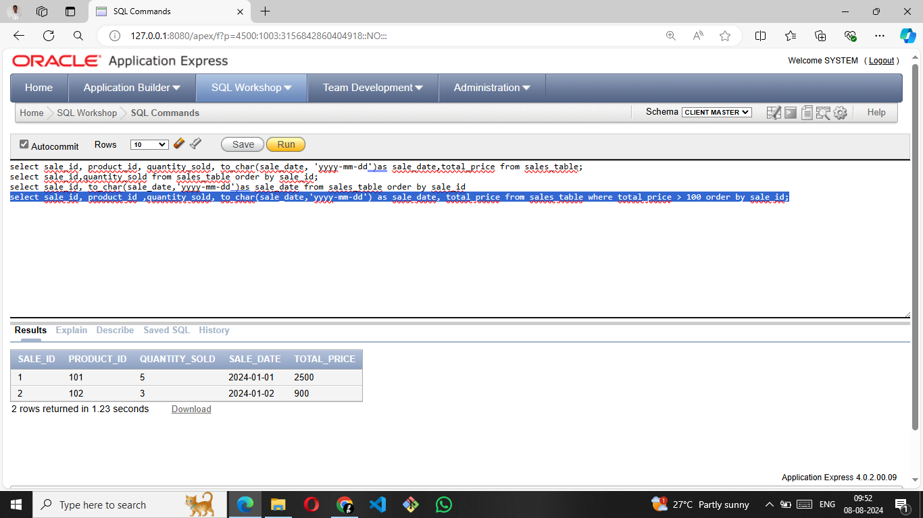

**5. Retrieve the sale_id and total_price from the Sales table for sales made on January 3, 2024.**

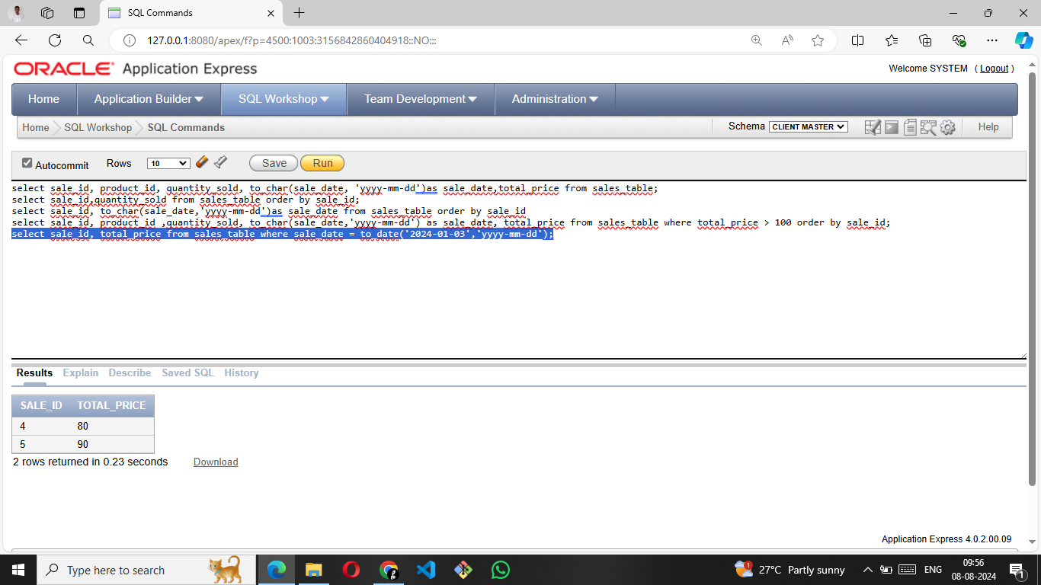

**6. Retrieve the sale_id, product_id, and total_price from the Sales table for sales with a quantity_sold greater than 4.**

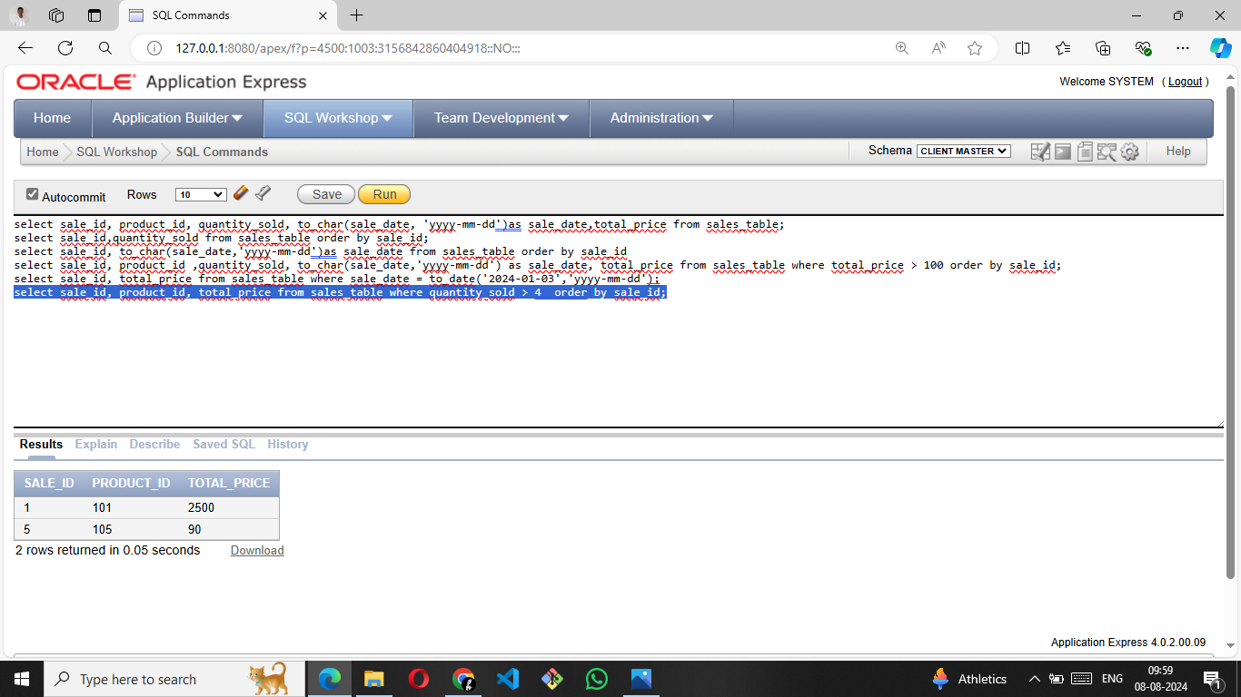

**7. Retrieve all columns from the Sales table those sale_id are 1, 3 & 5.**

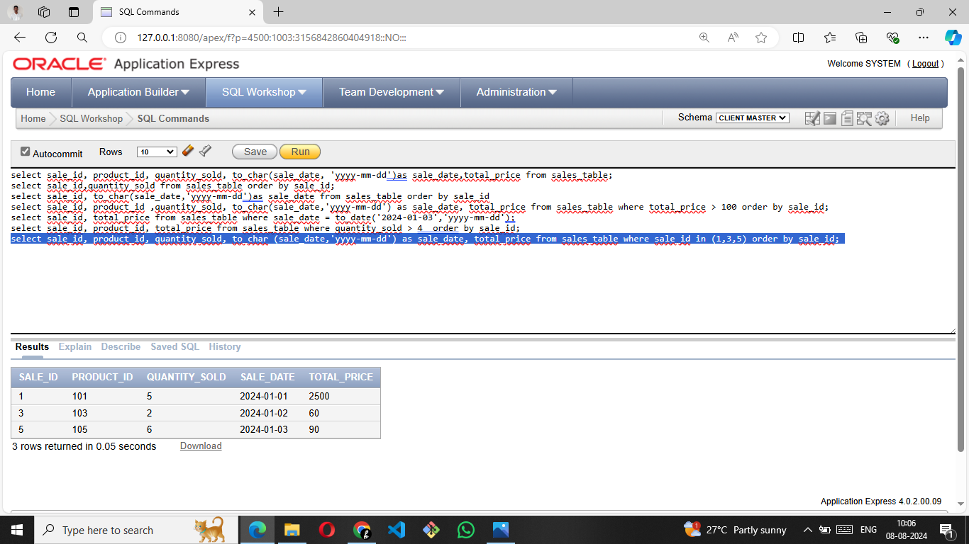

**8. Retrieve all columns from the Sales table those total_price between 90 and 1000.**

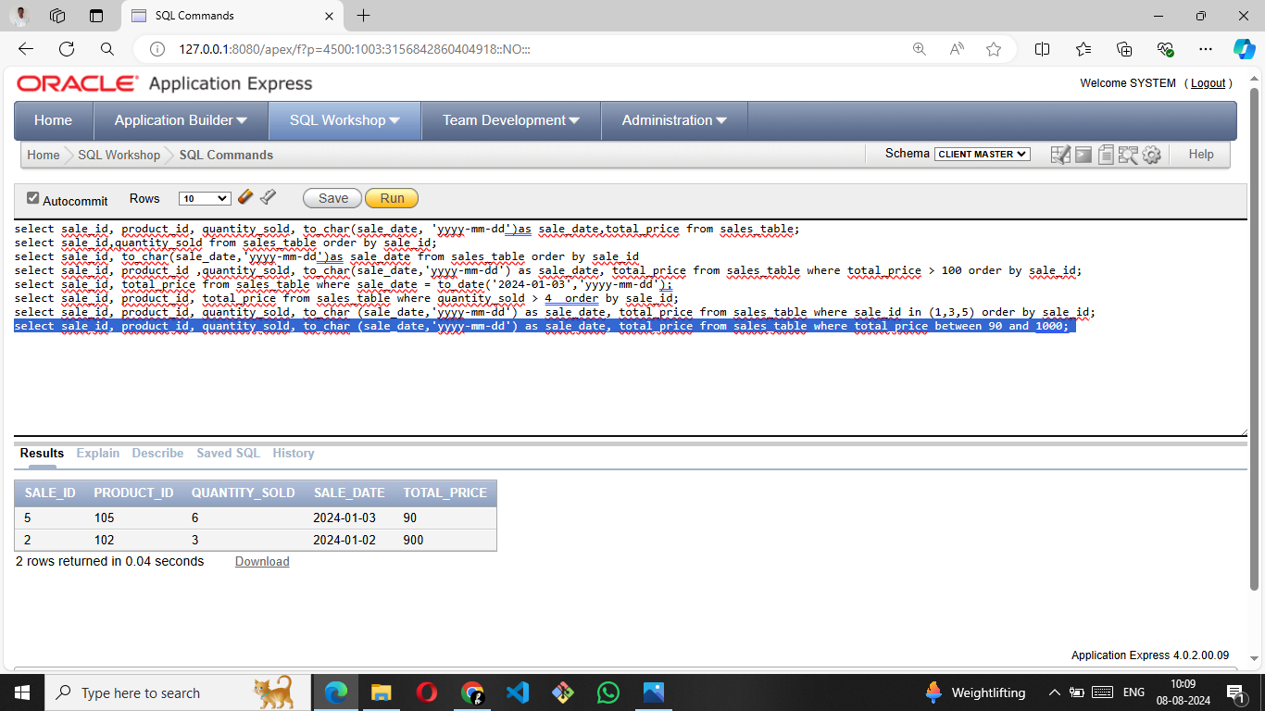

**9. Retrieve all columns from the Sales table those total_price not between 90 and 1000.**

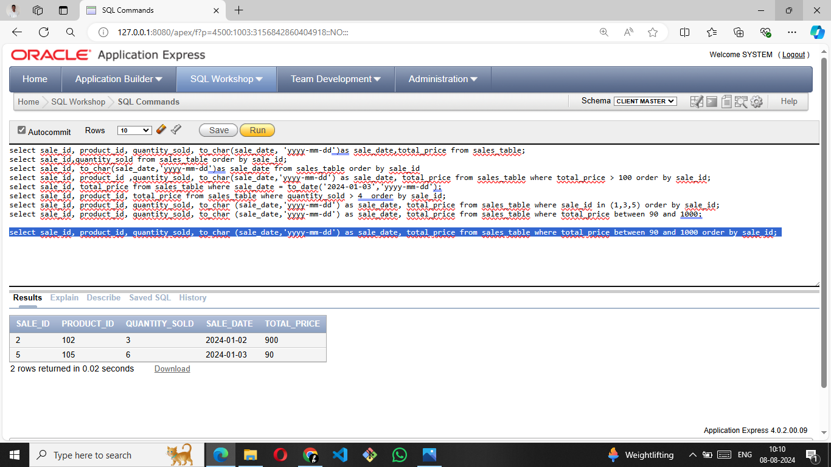

**10. Retrieve all columns from the Sales table those sale_id are not in 1, 3 & 5.**

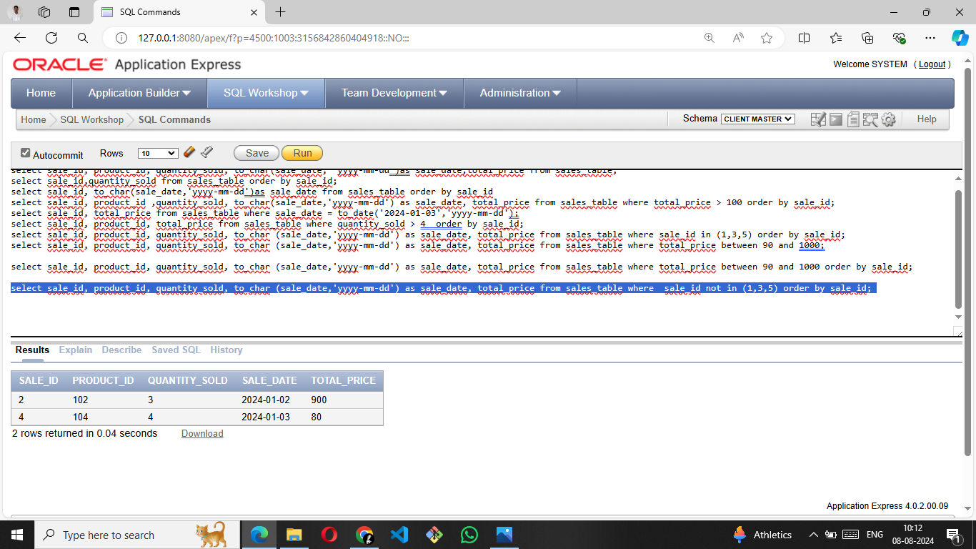

**11.  Update total_price as 500 in  the Sales table those sale_id are 1, 3 & 5.**

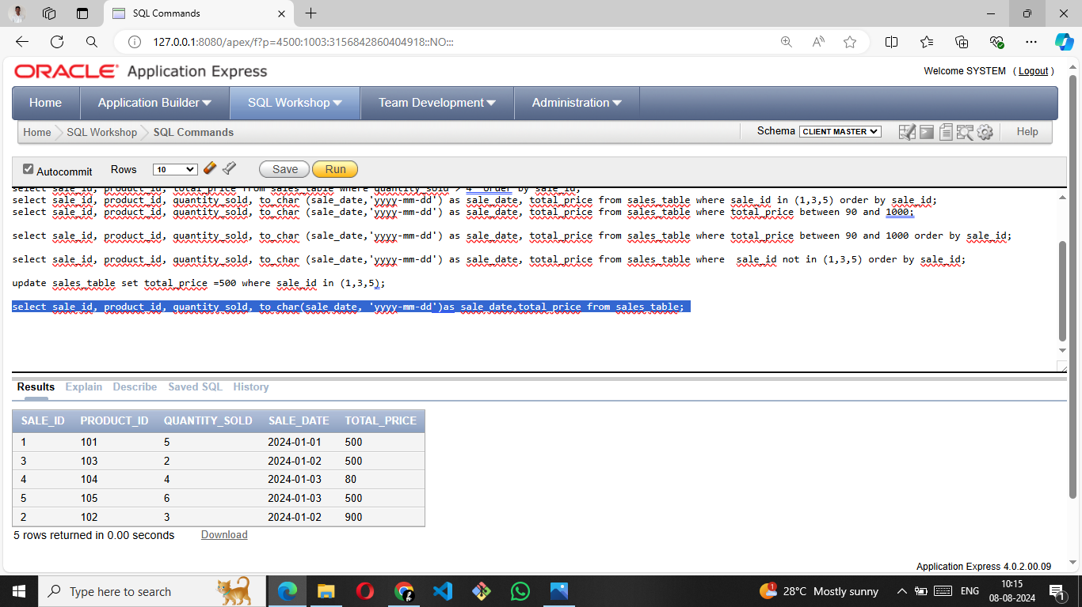

**12. delete from the Sales table those total_price not between 90 and 1000.**

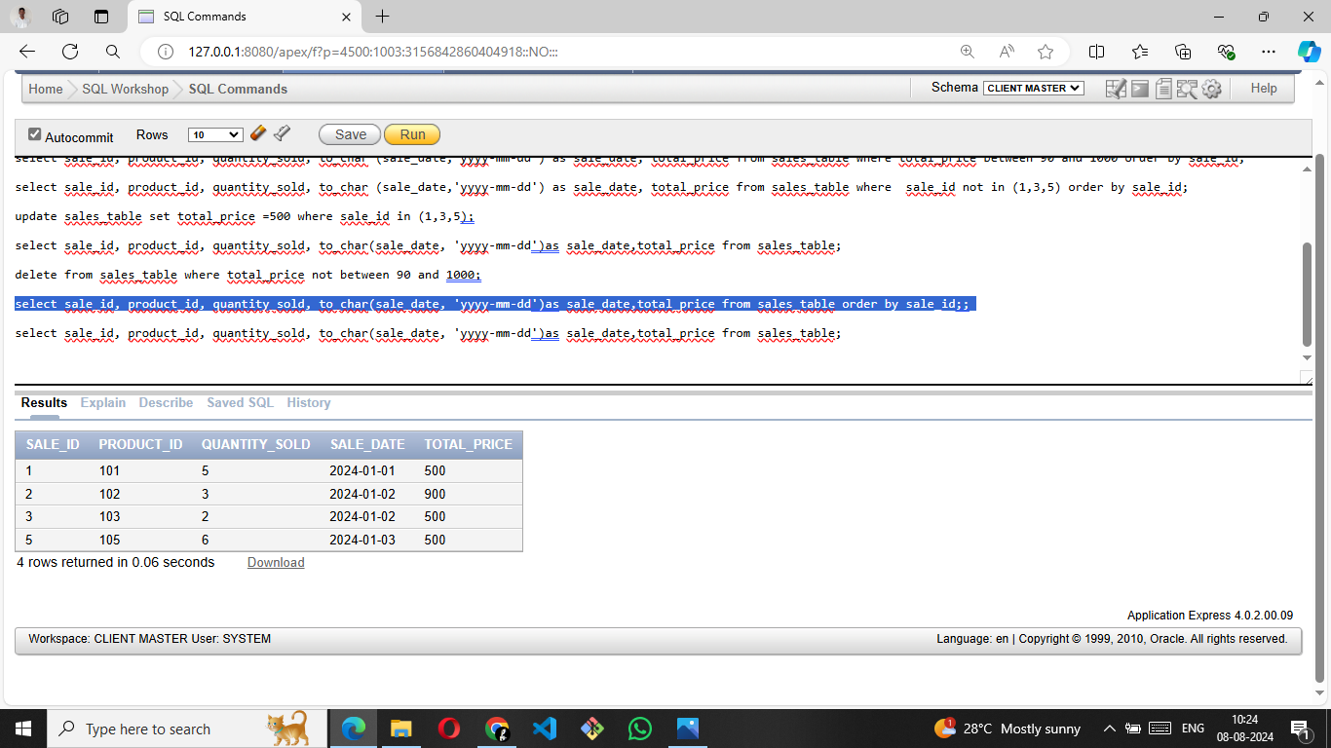

**13. Sort all the records using sale_id column in ascending order.**

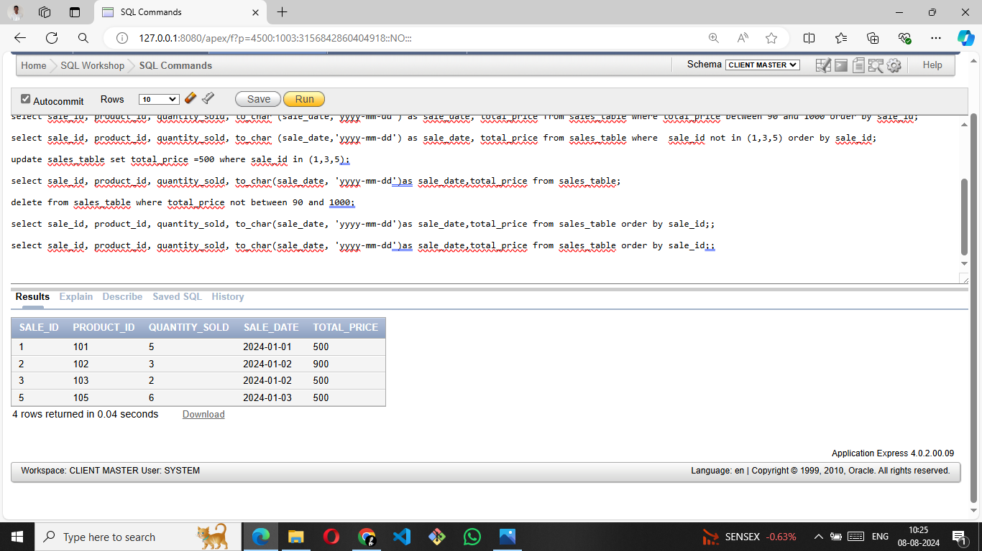

**14. Sort all the records using sale_id column in descending order.**

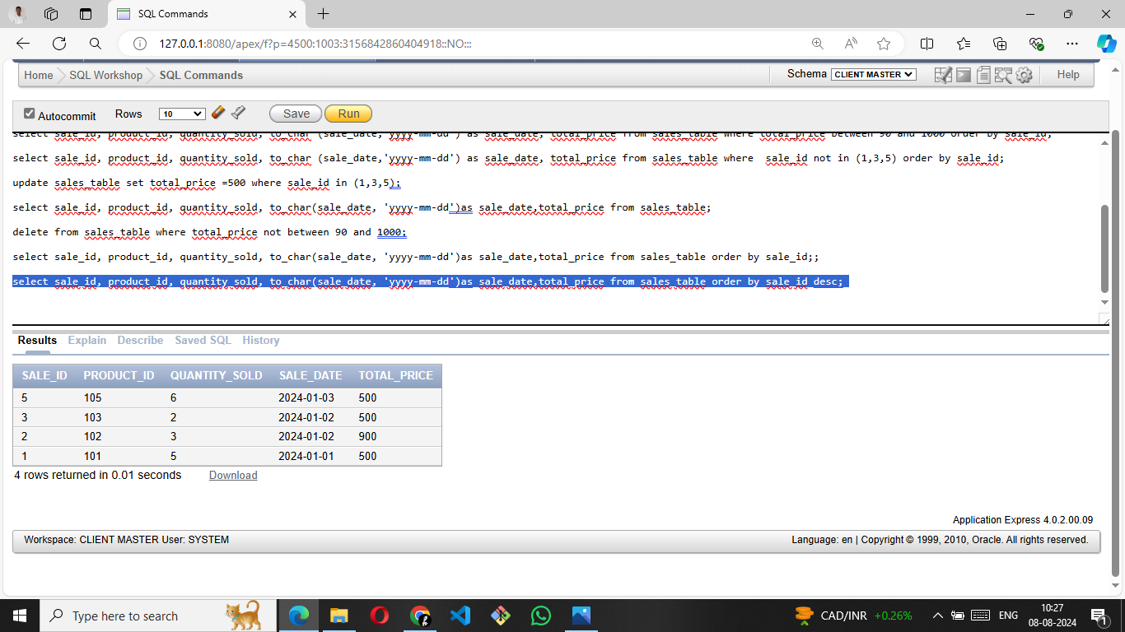

**15. Rename the sale_id column as sales_id;**

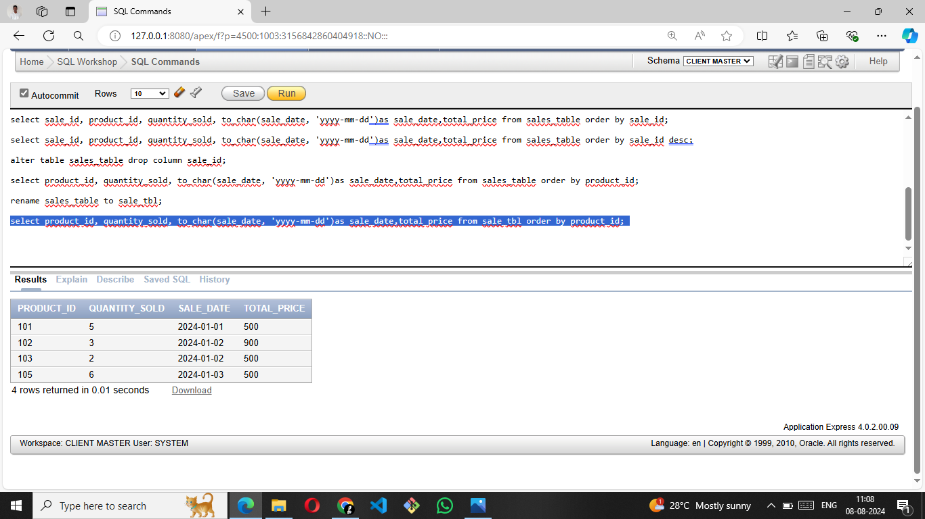

**16. Drop the column sales_id.**



**17. Rename the table as tbl_sales.**

